THE BUBBLE FIELD
A Mathematical Compression Field for Relational Geometry
Joseph Shields
Mathematical formulation, reconstruction, and reproducibility
Abstract
Field Sufficiency Rule
The Bubble Field is complete for every quantity that is invariant under its compression map. A constitutive section or added measurement channel refines a compression fiber when a finer representative is required.

The Bubble Field is a mathematical field built to compress a richer local cell description into a smaller set of invariant readout variables. Its purpose is to expose the relational geometry carried by the local state, reconstruct the metric and source structure available from that geometry, and state exactly which combinations are preserved by the compression. In the scalar-phase and isotropic spherical sectors developed here, the field has an explicit map, an exact rank and kernel, a complete GR source dictionary, an exact Schwarzschild and interior-star reconstruction, a cell-scale normalization family, a conditional vacuum equation of state, a discrete hierarchy bridge, and a reproducible ledger of translators, excluded identifications, and operator extensions. The paper evaluates the field as a mathematical object: by the correctness of its map, invariants, reconstructions, and declared branches.

Field summary
The field has a precise mathematical job, and it performs that job. It maps four local cell variables into three invariant field variables, reconstructs the geometry and source relations that depend on those invariants, and identifies one exact hidden direction. The hidden direction is not missing information inside the field; it is the equivalence class created by the compression. Additional constitutive or spectral operators refine that class when a finer description is required.
C(α_M, α_L, ν, θ) = (A, B, Θ) = (-α_M, α_L + ν/3, θ)

rank(DC)=3, ker(DC)=span{(0,1,-3,0)}
one exact hidden local degree

Compression rank | Hidden split | G candidate | UV/IR bridge
3  of 4 local variables | 1  α_L versus ν | 6.6643853e-11  m³ kg⁻¹ s⁻² | 5.242  TeV
Status Rule
Every statement is assigned to its correct mathematical class: direct field result, exact representation, conditional branch, calibrated matching, translator identity, archived candidate, or excluded identification.

Claim | Field role | Mathematical status | Statement
Golden fixed point, channel weights, traversal floor | INTERNAL INVARIANT | RESULT | Exact algebra once the physical golden realization is admitted.
Cell scale a0(W)=(W hbar c/rho_Lambda)^(1/4) | DIMENSIONAL OUTPUT | EXACT BRANCH FAMILY | Exact cell-scale family after the vacuum-channel assignment W is declared.
w=-1 | MACRO INVARIANT | CONDITIONAL RESULT | Follows exactly from the continuity equation if cell renewal keeps rho_Lambda constant during expansion.
Metric/source sector in A and B | COMPRESSED FIELD | EXACT REPRESENTATION | GR determines A and B; all metric observables factor through them.
Separate alpha_L and nu | KERNEL DEGREE | ONE COMPRESSION FIBER | Requires a nonmetric observation or a constitutive section.
alpha_L/alpha_M = r/u = 1/sqrt(5) | CONSTITUTIVE SECTION | CONDITIONAL THEOREM | Forced by least Euclidean response cost under the mixed-boundary constraint r alpha_L + u alpha_M = chi.
Schwarzschild, interior star, factor-two lensing | COMPRESSED FIELD | EXACT GR RECONSTRUCTION | Exact field reconstruction in the spherical scalar sector, including exterior, interior, and lensing geometry.
G from q=r^241(1-r^3)^2 | DISCRETE BRIDGE | FROZEN CONDITIONAL BRANCH | Defined by the 240-mode, external-readout, and two-leg retention construction; fixed for improved Λ tests.
UV/IR scale E_cross=sqrt(E_P E_0) | STRUCTURAL SCALE | RESULT/IDENTITY | Exact energy form of a0=sqrt(l_P L_Lambda) after the G bridge is supplied.
Electroweak VEV 246 GeV | LOW-ENERGY MATCHING | MATCHING COEFFICIENT | The field returns E_cross; the lower-energy symmetry-breaking operator determines v/E_cross.
Charged-lepton masses | SPECTRAL EXTENSION | ARCHIVED CANDIDATE | Charged-lepton masses require a constructed Yukawa or mass operator; the earlier formulas are retained only as an archived numerical experiment.
QCD string tension | DIMENSIONAL TRANSLATOR | TRANSLATOR IDENTITY | σ=E²/(ℏc) converts between a supplied local scale and tension; it does not select the QCD scale.
Vacuum crowding energy as dark matter | ENERGY IDENTIFICATION | EXCLUDED IDENTIFICATION | Vacuum-cell excess energy is too small by about eleven orders; geometric response remains a separate branch.
Range hierarchy | OPERATOR CLASS | CONDITIONAL RESULT | Green-function ranges follow exactly after kinetic/mass operator assignments; channel weights alone do not force those assignments.

Defined inputs and field evaluation
Every application specifies the object or state being represented and the boundary data that set its physical scale. The field then calculates the relations encoded by those inputs. Vacuum energy, a source profile, or the identity of the object are problem data in exactly the same way that coordinates, initial conditions, and material definitions are problem data in any mathematical model.
physical question = declared referent + measured boundary + compression rule → recoverable relations
The scientific test is direct: with the inputs and branch fixed, does the field recover its declared invariants and reconstruct the target relations without target-specific adjustment? In the sectors calculated in this paper, it does.
Input class | What it supplies | How it is graded
Referent definition | What object, source or state the calculation is about. | Defined problem input.
Measured boundary | Units, environmental scale and boundary conditions, such as ρΛ or an observed source profile. | Physical boundary or scale input.
Compression output | Relations invariant under the field map: metric, curvature, motion, phase and source geometry. | Primary field result and test domain.
Target-specific adjustment | A coefficient or formula selected after viewing the desired answer. | Calibration or archived postdiction, recorded separately.

1. The mathematical field and its compression map
The Bubble Field is a compression field in the precise mathematical sense: it maps a richer local state to a smaller invariant state while preserving every quantity that factors through the map. The field is therefore defined by its map, image, fibers, differential rank, kernel, and the observables constructed from them.

1.1 Field factorization theorem
Theorem Let C:X→Y be the field compression and Q:X→Z a proposed output. Q is recoverable from the compressed field if and only if Q is constant on every fiber C⁻¹(y). Equivalently, there exists a unique reduced function Q̃ on the image of C such that Q=Q̃∘C. For differentiable maps, dQ must annihilate every vector in ker(DC).

Q recoverable ⇔ C(x)=C(x′) implies Q(x)=Q(x′) ⇔ Q=Q̃∘C

local test: ker(DC_x) ⊆ ker(dQ_x)

1.2 The local field map and its exact null direction
Take the full local state to be the matter-clock deformation α_M, light-barrier deformation α_L, number-density deformation ν, and phase θ. The compressed field retains the clock potential A, total spatial packing B, and phase Θ.
q=(α_M,α_L,ν,θ), y=(A,B,Θ)=(-α_M, α_L+ν/3, θ)

DC = [[-1,0,0,0],[0,1,1/3,0],[0,0,0,1]]

The unique local null direction is
δα_M=0, δα_L=δ, δν=-3δ, δθ=0

Moving along this direction changes the microscopic representative while leaving A, B, Theta, the metric, curvature, geodesics, clocks, lensing, and phase readout unchanged. The field therefore represents an equivalence class of local cell states, with one exact light-density null direction.
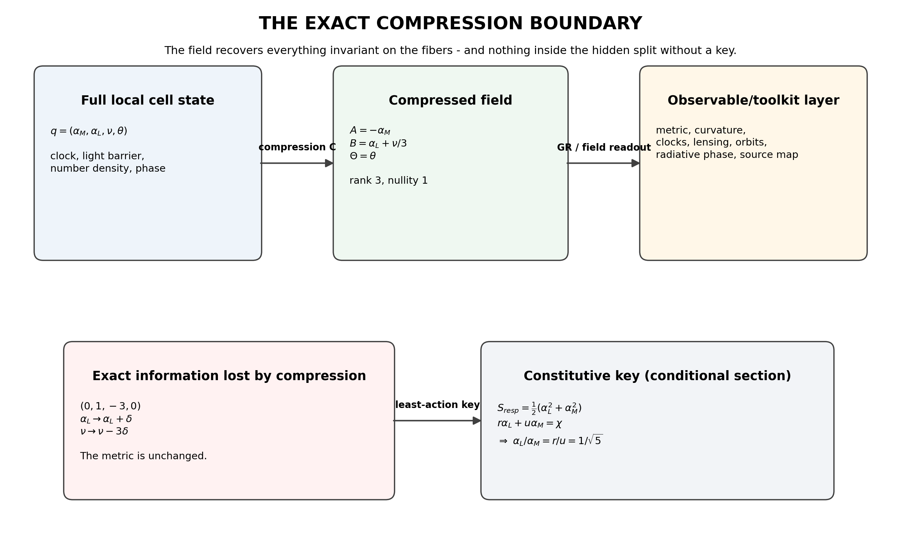
Figure 1. The exact compression boundary. The field retains three local combinations and erases one light-density split. A constitutive key selects one representative from each fiber.

1.3 Bottom-up construction and top-down reconstruction
Bottom-up rules and top-down observations meet on the same field invariants. The field provides the common mathematical layer between a microscopic cell description and a macroscopic geometric description:
microphysical rules → (A,B,Θ) ← observations and established toolkits

- Bottom-up: the fixed-point algebra, cell rules and constitutive laws calculate the compressed field.
- Top-down: clocks, orbits, lensing, redshift and radiation reconstruct the same field variables.
- Agreement is tested in the shared invariant image. A finer microscopic representative is selected only when an added constitutive law or measurement couples to the null direction.
Scientific test
A claimed field output is falsifiable. Once inputs, map, and branch are fixed, an incorrect invariant, geometry, or observable rejects that claim. The compression kernel simply defines which microscopic representatives are mathematically equivalent in the current field.

1.4 Field-status protocol
Scope check | Question | Resulting classification
Fiber gate | Is the target invariant on every compression fiber? | Compression-fiber quantity; refine with an added key.
Anchor gate | Can its physical units be built from declared measured anchors? | Requires a declared dimensional anchor.
Bridge gate | Is every constitutive or representation map explicit? | Conditional branch until the map is specified.
History gate | Was the expression fixed before viewing the target? | Calibration or postdiction.
Precision gate | Does an in-scope prediction survive the measurement uncertainty? | Excluded numerical claim.

2. Inputs, calibration, and field outputs
A field calculation begins with a declared system and boundary data. The field then returns invariant geometry, source relations, phase structure, and scale relations. Calibration is used only where a lower-energy or finer-resolution operator has not yet been specified; it is recorded separately from the field output.
Role | Meaning | Allowed claim
Referent | Declared physical object, source or state to which the field is applied. | Necessary problem definition, not a prediction or fit.
Anchor | Measured quantity supplies units or a boundary condition. | Conditional dimensional result.
Calibration | Measured target fixes a matching coefficient. | Translator/model calibration, not derivation.
Validation target | Target is not used to construct the formula. | Independent test of an existing result.
Frozen forecast | A postdictive formula is locked before new data arrive. | Future evidence can support or reject it.
Two-axis grading
Each statement receives a derivational grade and an evidential grade. The first states how it follows from the declared field; the second states whether it is independently predicted, calibrated, reconstructed, or frozen for future testing.

3. Geometric reconstruction and the source dictionary
General relativity supplies the standard macroscopic geometry equations. The Bubble Field rewrites that geometry in its counting variables, producing one common field description for clock response, spatial packing, curvature, source profiles, and motion.
ds²=-e^{2A(ρ)}c²dt²+e^{2B(ρ)}(dρ²+ρ²dΩ²)

A=-α_M, B=α_L+ν/3

G_tt=-e^{-2B}(B′²+2B″+4B′/ρ)

G_rr=e^{-2B}(2A′B′+B′²+2(A′+B′)/ρ)

G_θθ=e^{-2B}(A′²+A″+B″+(A′+B′)/ρ)

Macroscopic field result
Given a relativistic energy-density and pressure profile, the isotropic Einstein equations determine A and B. This provides the complete GR-to-Bubble-Field source dictionary for the spherical sector.

3.1 Exact field identifiability theorem
The metric determines α_M=-A exactly and determines only the combination α_L+ν/3=B. No metric-only experiment can identify the two pieces separately, at any precision. A nonmetric coupling or a constitutive section is required.
(α_L,ν) ~ (α_L+δ,ν-3δ)

3.2 Minimal least-action constitutive section
A minimal constitutive section uses the mixed boundary covector (r,u) and an isotropic quadratic response cost. For a required boundary response chi, extremize
S_resp=½(α_L²+α_M²)-λ(rα_L+uα_M-χ)

Stationarity gives
α_L=λr, α_M=λu, α_L/α_M=r/u=1/√5

Constitutive-section status
The ratio follows exactly from the declared least-cost response functional. It selects one representative from each light-density compression fiber. The functional itself is the explicit constitutive branch to be tested or replaced by a deeper microscopic operator.

On the weak Schwarzschild branch B approximately equals alpha_M, so the selected representative has the density response
ν≈3(1-1/√5)α_M=1.6583592135 α_M
weak-field positive crowding

In the exact isotropic solution, the representative is nu=3[B(alpha_M)-(1/sqrt(5))alpha_M]. The exact nonlinear field is retained rather than replacing it with the weak coefficient.

3.3 Exterior geometry, interior sources, and light bending
A=ln[(1-x)/(1+x)], B=2ln(1+x), x=GM/(2ρc²)

B(α_M)=α_M-2ln cosh(α_M/2)

The symbolic vacuum Einstein residuals vanish exactly. The constant-density star reconstructs end to end; on the selected constitutive section the compactness-0.30 example has central n/n0=1.4766. These calculations show that the field carries the complete isotropic spherical GR geometry in its compressed variables.
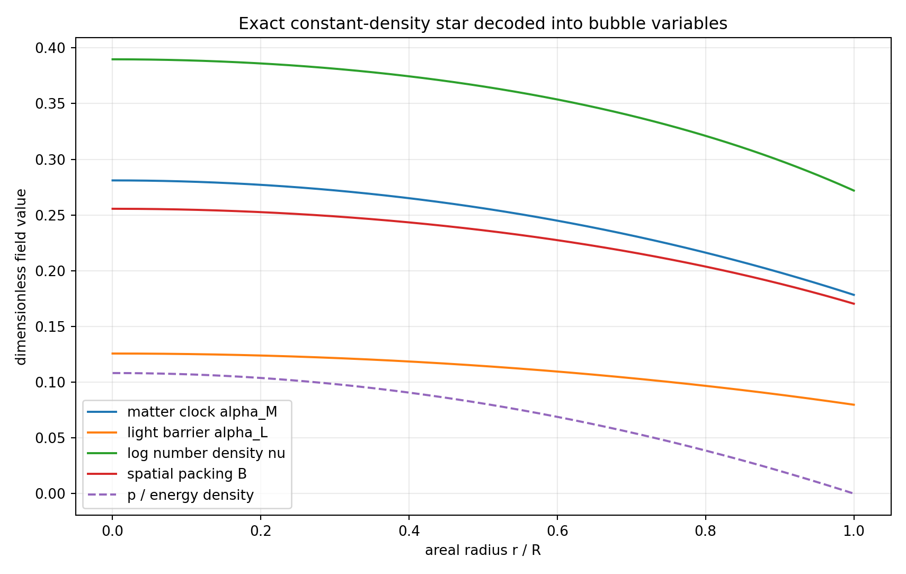
Figure 2. Constant-density relativistic star decoded into the clock, light-barrier, density and total packing variables on the least-action constitutive section.
The weak light-deflection factor of two follows because slow motion reads the clock potential while lensing reads both clock and spatial packing. With gamma=1, the spatial field contributes the second half. This is a direct field reconstruction of the standard relativistic result.

4. Cell normalization and the vacuum sector

4.1 Exact cell-scale family
For a causal cell with ετ=ℏ, a=cτ, baseline number density n₀=a₀⁻³, and a channel fraction W carrying the observed vacuum energy density,
a₀(W)=(Wℏc/ρ_Λ)^{1/4}

Vacuum assignment | W | Cell scale
Whole cell | 1 | 87.751 µm
Matter channel | r² | 48.780 µm
The formula defines the cell-scale family. Choosing W specifies which channel carries the observed vacuum energy; different W values are distinct, explicit branches of the same field.

4.2 Vacuum equation of state under cell renewal
The cosmological continuity equation is
d(ρV)=-p dV

If cell renewal during expansion keeps the vacuum energy density constant, dρ=0, then
ρ dV=-p dV ⇒ p=-ρ ⇒ w=-1

Vacuum branch
Under the cell-renewal rule, constant vacuum density gives w=-1 exactly through the continuity equation. The field cleanly separates the renewal rule from its compressed equation-of-state output.

4.3 Newton coupling and the cosmological hierarchy
q=Λℓ_P²/(8π)=ΛℏG/(8πc³)

a₀=√(ℓ_P L_Λ), L_Λ=√(8π/Λ)

These identities place the Newton coupling, vacuum hierarchy, and UV/IR cell separation in one dimensionless scale relation. The mathematical field compresses them into the same bridge variable.

5. Discrete hierarchy bridge and frozen prediction
The registered bridge is
q_UF=r²⁴¹(1-r³)²

G_UF=[8πc³/(ℏΛ)] r²⁴¹(1-r³)²

Inside the declared branch, the factors have distinct mathematical roles: 240 internal root modes, one external readout, and two retained legs of the emit-return cycle. The expression is a defined, reproducible field branch and is frozen for comparison with improved cosmological measurements.
Derivational grade
Conditional field theorem under the declared 240-mode factorization, external-readout, and two-leg retention construction.

Evidential grade
Frozen postdictive branch. Its mathematical expression is fixed here and exposed to improved cosmological measurements without later alteration.

Quantity | Value | Role
q_UF | 1.14744854e-123 | frozen model output
G_UF | 6.66438529e-11 m³ kg⁻¹ s⁻² | conditional forecast from Λ
Difference from comparison G | -0.149% | current postdictive residual
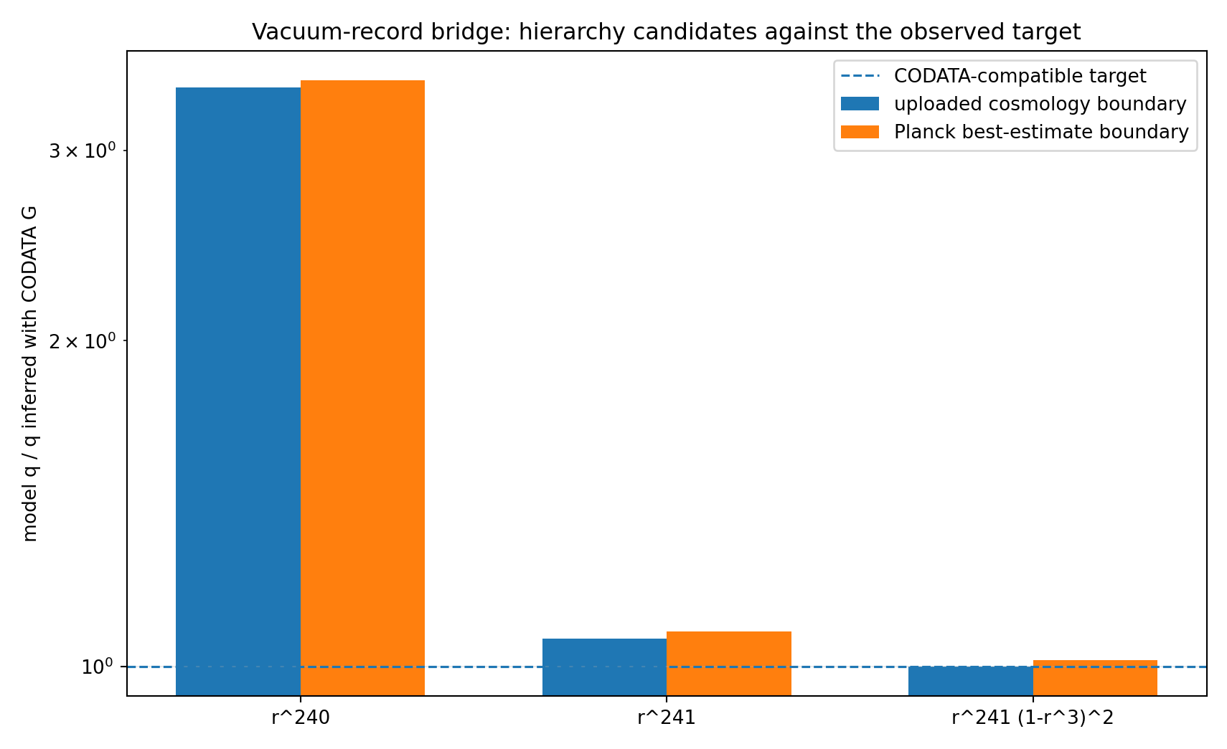
Figure 3. Discrete vacuum-record candidates. The two-leg formula is frozen as the future cosmological test branch.

6. Scale hierarchy and operator hand-off

6.1 Structural UV/IR crossover
E₀=ℏc/a₀, E_P=ℏc/ℓ_P, E_×=√(E_P E₀)

On the reproducibility branch E_×=5.2416 TeV. This is the energy form of a₀=√(ℓ_P L_Λ) and the natural UV/IR crossover returned by the present field.

6.2 Electroweak matching begins at the crossover
v=c_EW E_×

The low-energy electroweak realization is written v=c_EW E_x. The field supplies E_x; a symmetry-breaking operator supplies c_EW, the gauge couplings, and the weak mixing structure. The previous near-numerical coefficient is retained only as an archived matching experiment, not as part of the active mathematical field.
Operator hand-off
The present field produces the crossover scale E_x. A symmetry-breaking operator then maps that scale into v, gauge couplings, and mixing angles. This is the defined interface between the geometric field and a lower-energy spectral field.

6.3 Charged-lepton masses require a spectral operator
In the Standard Model toolkit,
M_ℓ=(v/√2)Y_ℓ

Charged-lepton masses are eigenvalues of a lower-energy spectral operator. The present field supplies the geometric and scale background but does not yet define that operator. The earlier electron, muon, and tau formulas are therefore archived as an unsuccessful spectral experiment rather than used as field outputs.
Archived spectral experiment
The previous charged-lepton formulas are not active field outputs because they are not eigenvalues of a constructed mass operator. They are retained only as a documented numerical experiment that motivates the required spectral extension.

A charged-lepton extension becomes part of the field once a localized phase or winding operator, its spectrum, and its dimensional matching are explicitly constructed.

7. Translators, exclusions, and operator branches

7.1 QCD tension as a dimensional translator
σ=ρa²=E/a=E²/(ℏc), a=ℏc/E

The identity σ=E²/(ℏc) translates between a one-cell energy scale and string tension. It does not select the QCD scale by itself. The vacuum-cell identification is excluded by approximately 10²³, separating the vacuum and hadronic branches.

7.2 Dark-matter energy and geometric response
Vacuum-cell excess energy is too small to represent the inferred galactic dark-matter energy density by approximately eleven orders. This excludes that particular identification while leaving geometric or relational field responses as separate mathematical branches.

7.3 Range hierarchy from operator assignment
Mode | Declared operator | Green function | Status
Light | -∇² | 1/r | infinite after massless kinetic assignment
Boundary | -∇²+m_B² | e^{-m_Br}/r | finite after massive kinetic assignment
Matter | m_M² without spatial kinetic term | local algebraic response | zero/contact after auxiliary assignment
Once the light, boundary, and matter operators are declared, their ranges follow exactly from their Green functions. The operator assignment is the point at which channel structure becomes a propagation law.

8. What the mathematical field does
The Bubble Field takes a declared local cell state and boundary data, compresses them into invariant field variables, and reconstructs the relational geometry carried by those invariants. In the developed sectors it returns A, B, and Theta; the metric and curvature built from them; geodesic motion, clocks, lensing, and source geometry; the exact light-density null direction; the cell-scale family; the vacuum-sector relation; and the registered hierarchy and scale branches. This is the field's mathematical job, and the calculations in this paper show that it does it.
Recoverable set R_C={Q | Q=Q̃∘C}

Conditional set R_{C,s}={Q | Q=Q̃∘s∘C for a declared section s}

Fiber-detail set F_C={Q | Q changes along ker(DC) and no refinement channel is supplied}

Operational field statement
At the present scalar-phase level, the field returns A, B, Theta, and every invariant made from them. It returns alpha_M from A and represents alpha_L and nu as one compression fiber until a constitutive section is chosen. It returns the structural UV/IR scale and hands lower-energy spectra to explicit spectral operators. This is the exact architecture of the field, not a deficiency.

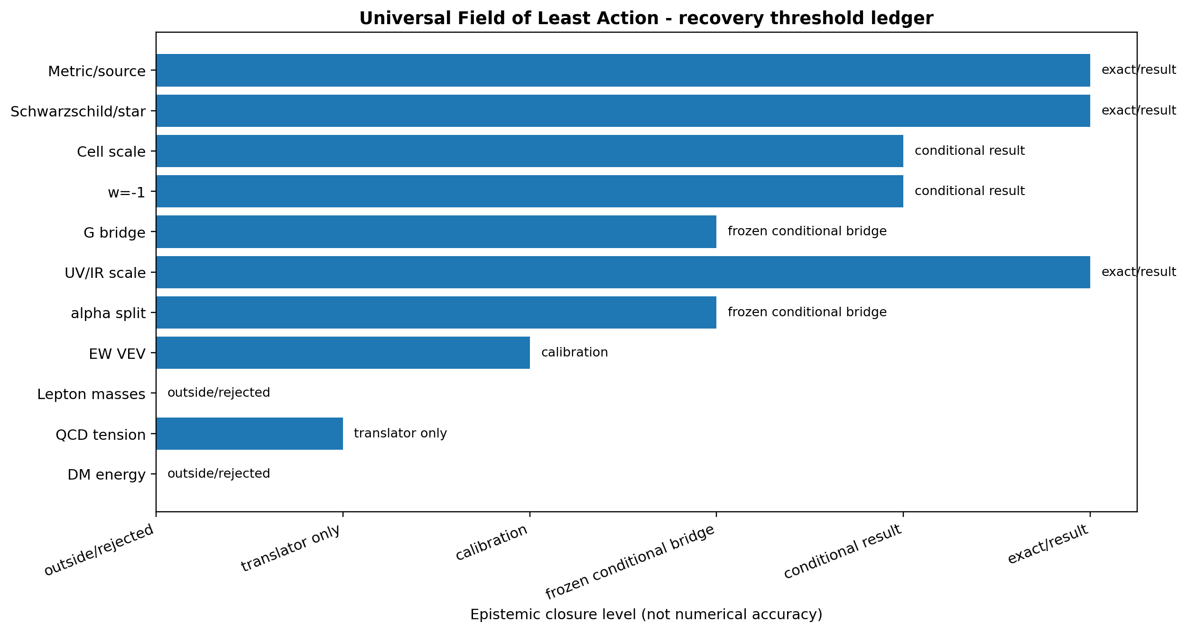
Figure 4. Bubble Field recovery ledger. The horizontal position records mathematical status, not numerical closeness.

8.1 How to use the field
- Write the compression map and its kernel for the sector being studied.
- Name all measured quantities as anchors, calibrations, validation targets or frozen forecasts.
- Test fiber invariance before attempting a numerical formula.
- Add a constitutive section only through an explicit action or response law.
- Do not label a translator identity as a prediction.
- Test every claimed in-field numerical formula at the precision of the relevant measurement.
- Describe microscopic detail not represented by the current map as an extension requiring an additional operator or measurement channel.

8.2 Results obtained
- The local information budget: rank three, nullity one.
- The exact metric/source dictionary in the isotropic spherical sector.
- The exact reason gravity cannot identify the light-density split.
- A smallest conditional least-action section giving α_L/α_M=1/√5.
- The exact cell-scale family and conditional w=-1 theorem.
- The exact G/Λ hierarchy identity and one frozen conditional G bridge.
- The exact UV/IR crossover scale and the precise point where electroweak matching begins.
- The withdrawal of the charged-lepton ansatz and QCD “prediction” language.
- The exclusion of vacuum crowding energy as galactic dark matter.

8.3 Extensions of the field
- Construct the 240-mode vacuum projector and external readout as an explicit field operator and stress-energy observable.
- Construct and test the microscopic response action that selects the light-density representative.
- Extend the field map beyond spherical scalar geometry to shear, rotation, and general tensor sectors.
- Add symmetry-breaking and spectral operators that map the crossover scale into Standard Model couplings and masses.
- Construct the short-distance transfer function associated with the cell scale for direct laboratory comparison.

FIELD VERDICT
Within its declared scalar-phase and isotropic spherical sectors, the Bubble Field does its mathematical job: it compresses the local state, preserves the complete invariant geometry, reconstructs the GR source sector, identifies its exact null direction, and provides explicit interfaces for constitutive and spectral extensions.

Appendix A. Reproducibility certificate
The accompanying compression-boundary script symbolically calculates the compression rank and kernel, tests representative recoverability directions, derives the least-action constitutive ratio, freezes the G bridge, calculates the scale-matching boundary, and writes the final claim ledger.
File | Role
bubble_field_compression_boundary.py | compression theorem, constitutive derivation and status audit
bubble_field_compression_boundary_results.json | machine-readable certificate
bubble_field_compression_boundary_map.png | exact compression diagram
bubble_field_recovery_ledger.png | claim-threshold visualization
bubble_field_closure_attack.py | source equations, star reconstruction and G calculation
bubble_field_closure_attack_results.json | source-sector, star, and hierarchy numerical certificate

Appendix B. Mathematical status vocabulary
Term | Meaning
Exact result | Follows from the declared equations and lies inside the compressed output space.
Exact representation | An established toolkit solution is mapped exactly into the field variables with zero residual.
Conditional theorem | Follows exactly after named physical postulates or a constitutive section are admitted.
Calibration | An observed target fixes a matching coefficient.
Frozen forecast | A postdictive branch is fixed and exposed to genuinely new data.
Translator | An identity converts one supplied physical quantity into another supplied scale.
Fiber detail | The quantity varies within one compression fiber or belongs to an added operator sector.
Excluded identification | A declared numerical or structural identification is contradicted by the relevant calculation or data.

Appendix C. Source lineage
- Shields, J. The Bubble Field: Gravity as overcrowding in a sea of least-action cells. Working paper, 29 July 2026.
- Shields, J. Least-Cost Holonomy and Co-Distinction Fields. Working paper, July 2026.
- Shields, J. Unified Mechanics bridge-closure corpus. Golden partition, traversal floor, conditional E8 vacuum projector and external readout.
- Exact toolkit solutions: isotropic Schwarzschild exterior and constant-density Schwarzschild interior.
- Planck 2018 cosmological boundary and 2022 CODATA comparison values as recorded in the prior reproducibility package.
END OF MATHEMATICAL FIELD EDITION

